1. If you export in JSON, then extended JSON strict mode will be used. It means that type information will be preserved using special key-value pair where key represents name of the type.
2. 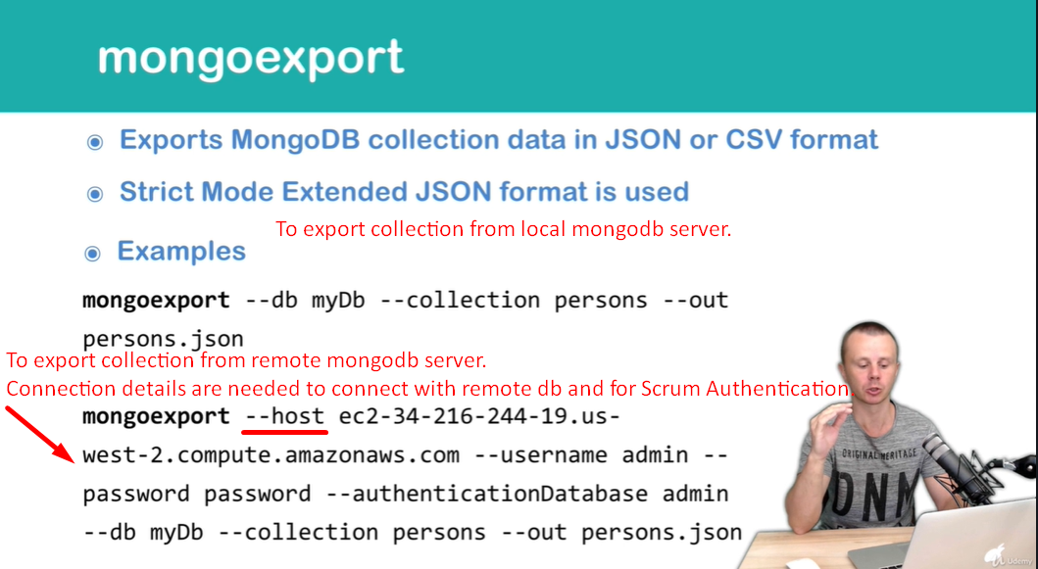
3. 